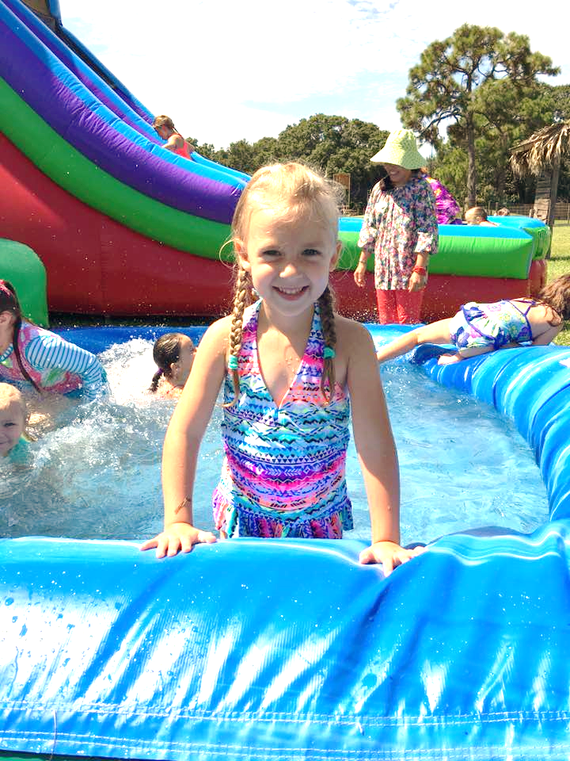

Foundations
Summer
Programs
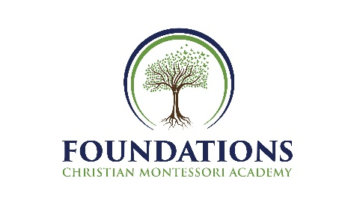
Foundations
Summer
Programs

At Foundations, we will be spending the summer of 2019 promoting academic learning with a particular emphasis on Science! From Infants to Kindergarteners, we will provide fun, engaging activities and books to enlighten and enhance our students’ awareness of Outer Space and Pre-Historic animals! In June we will explore “Our Place in Space” and in July we will be “Diggin’ with the Dinos!” Then we will add a splash of water play, bubbles and crafts to augment our themes. The children enjoy the relaxed atmosphere and opportunities to hear about science topics, do experiments, and make artistic masterpieces with various medium that reinforce their knowledge of our themed topics.

Infants and Toddlers:
During the summer, our infants and toddlers are exposed to many books and photographs to increase their vocabulary and pre-reading skills. We are also very aware of their need to have tactile experiences with in their environment and provide many fun experiences to stimulate and strengthen their gross motor development while learning about our fun science themes each month!

Primary – Kindergarteners:
Summer is a perfect time for our growing preschoolers and kindergarteners to practice experiments, hear about scientific topics, and grow their knowledge of the world around them. We will be using our exciting science themes to create interesting projects, games and activities that engage our students and increase their academic skills! In addition, children get to have plenty of play time with water activities during the hotter days of summer!

Call us at 941-907-7078 if you have any questions!

Summer Weeks:

Session # I- “Our Place in Space”
4 weeks- From June 3rd -June 28th

Session # II- “Diggin’ with the Dinos!”
4 weeks – From July 1st-July 31st (Closed on July 4th & 5th in honor of Independence Day)
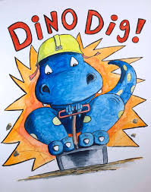

Full Day hours: 8:00 AM -3:00 PM
Extended Day hours: 7:30 AM – 5:30 PM

